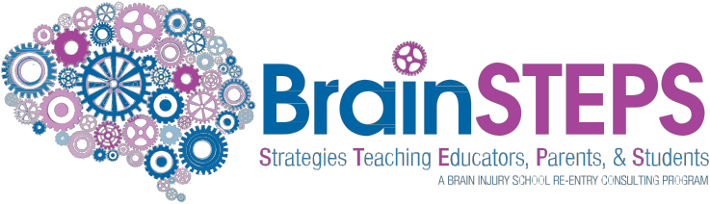

www.brainsteps.net

BrainSTEPS

The BrainSTEPS (Strategies Teaching Educators, Parents, & Students) Brain Injury School Re-Entry Consulting Program assists Pennsylvania schools in creating educational plans for students fol- lowing acquired brain injury. Acquired brain injuries (ABI) are brain injuries that occur after birth and include both traumatic brain injuries (TBI) and nontraumatic brain injuries (nTBI).

After a brain injury, students may return to school with temporary or lifelong impairments that have a significant impact on classroom performance. BrainSTEPS has been designed to consult with school teams and families in
the development and delivery of educational services for students who have experienced any type of acquired brain injury. BrainSTEPS assists schools in building their capacity by serving as brain injury consultants to the school districts and teachers of these students.

• BrainSTEPS works to not only re-enter
students from hospital/rehabilitation
to school after a new brain injury, but
with students previously identified as
having a brain injury who may begin
to develop educational impacts over
the years as their brains mature and
develop.

• Thirty BrainSTEPS teams are based out of the educational intermediate units and three large school districts.

• Education professionals, medical rehabilitation professionals, and family members comprise the BrainSTEPS teams.

BrainSTEPS serves the following types of acquired brain injuries:

Concussions (mild TBI), moderate and severe Traumatic Brain Injuries caused by sports/ recreational activities, falls, assault, abuse, motor vehicle accidents (includes bicycle), pedestrian accidents, and shaken baby syndrome.

Non-Traumatic Brain Injuries caused by stroke,
brain tumor, aneurysm, lack of oxygen to the brain,
lightning strikes, chemotherapy/radiation impacts
to the brain, near drowning, seizure disorder, brain
infections (encephalitis, meningitis), toxic or meta-
bolic injury, and viruses.

BrainSTEPS supports school districts in the following ways:

• Identification of students with traumatic and
nontraumatic brain injuries

• School re-entry planning

• Intervention selection and implementation

• Educational plan development

• Concussion management for return to
academics

• Teacher training, peer training,
family training

• Ongoing, annual monitoring until graduation

• Family support and resource sharing

• Awareness training to medical,
rehabilitation, and community facilities

Brain injury facts:

• Brain injury is a leading cause of death and disability in children and adolescents.

• Physical recovery is not a sign that the brain has healed. You can’t gauge recovery from brain injury based on how a child looks on the outside.

• Brain injury severity does not equate with how the student will function academically or socially/emotionally in school.

• A concussion is a mild traumatic brain
injury and can have lifelong effects.

• Students do not need to strike their heads to sustain a brain injury. A sudden jolting motion of the head may be all the force that is necessary to cause a brain injury.

• It is not common to lose consciousness after a concussion. Less than 90 percent of concussions involve a loss of consciousness.

• Children do not simply “bounce back” after brain injury. In fact, injury to the developing brain can impact future learning.

• Effects of brain injury are not always immediately apparent and may not become evident until the child passes through important developmental stages. Over time, difficulties may emerge as the demands are increased on parts of the brain originally injured.

How to Make a BrainSTEPS Referral

The BrainSTEPS Team will accept referrals from school districts, agencies, parents, physicians, early intervention service providers, or any other service providers.

Go to www.brainsteps.net

Click on Make a Student Referral to make an electronic referral

or

Contact your local BrainSTEPS team directly:

For schools in Carbon and Lehigh Counties,
please contact the following Carbon Lehigh Intermediate Unit 21 Staff:

Danielle Argot, Team Leader
argotd@cliu.org

For general BrainSTEPS Program information
contact:

Brenda Eagan Brown M.Ed., CBIS
BrainSTEPS Program Coordinator Email: eaganbrown@biapa.org Phone: 724-944-6542

www.brainsteps.net

The BrainSTEPS Program is jointly funded through the Pennsylvania Department of Health and the Pennsylvania Department of Education, and is implemented through the Brain Injury Association of PA.

DEPARTMENT OF HEALTH

February 2016 Update

